Project Maverick – RTR
Technical Lean Specification

Interface – 1 Finance to Oracle Cloud GL
(RTR_GL_INT_009)

Document Control Information
Document Information
Document Identification | RTR_GL_INT_009
Document Name | 1 Finance to Oracle Cloud GL
Project Name | Project Maverick
Client | Dell
Document Author | Deloitte Project Maverick RTR Team
Document Version | V2.0
Document Status | Draft
Date Released | 04-07-2025
Document Edit History
Version | Date | Additions/Modifications | Prepared/Revised by
1 | 01-11-2024 | Initial version | Deloitte Project Maverick RTR Team
2 | 04-07-2025 | Changes with MOCK1 testing | Deloitte Project Maverick RTR Team
Document Review/Approval History
Date | Document Version | Name | Organization/Title | Comments
 | 1.0 | Vivek Pal | Deloitte (Manager)
 | 1.0 | Tapan Swain | Deloitte (Manager)
 | 1.0 | Manish Kumar | Deloitte (Tech Lead)
 | 2.0 | Ishwar Kumar | Deloitte (Tech Lead)
 | 2.0 | Praveen Jaiswal | Deloitte (Manager)

Distribution of Final Document
The following people are designated recipients of the final version of this document:
Name | Organization/Title

Table of Contents
1. Summary 6
1.1 Purpose/Justification 6
1.2 Interface Description and Overview 6
1.3 Business Rules 6
1.4 Sample Output 7
2. Technical Specification 8
2.1 Process Description 8
2.2 Design Approach 8
2.3 OIC Objects 9
2.3.1 OIC Integrations 9
2.3.2 OIC Lookups 9
2.3.3 OIC Connections 9
2.4 Database Objects 10
2.5 Data File Format 10
2.6 Web Services 10
2.7 BI Publisher Report Details 10
2.8 FBDI Processing 11
2.9 Archiving and Purging 11
2.10 File Layout / Report Output 11
2.11 Validation and Error Handling 11
3. Application Setup and Technical Requirements 13
3.1 Programs/Report and Parameters 13
3.2 ESS Program, Scheduling and Executables 13
3.3 Security and Controls Requirements 13
3.4 Archiving & Purging 13
3.5 Rollback and Recovery 13
3.6 Miscellaneous 13
4. File and Directory Locations 14
5. Technical Unit Test 15
6. Interface/Conversion Reporting Requirements 16
6.1 Data Validation & Error Reporting 16
6.2 Data Reconciliation 16
7. Open and Closed Issues 17
7.1 17
Open Issues 17
7.2 Closed Issues 17
8. Appendix 18

Summary

Purpose/Justification

As an Integrated System, Dell Technologies Inc. seeks to optimize and standardize processes and data across the organization, align to best practices and maximize worker productivity.
As part of Oracle Cloud ERP Financials Implementation, Oracle Cloud General Ledger will be implemented replacing the existing 1Finance GL application for Financials. Oracle Fusion General Ledger will become Dell Technologies Inc. system of record for GL Journal entries.
Dell Technologies Inc. intends to continue the use of 1Finance applications for business functions during the interim state for operations until a true end state system architecture is enabled. Hence, generation of accounting entries for all the business transactions will continue to be posted into 1Finance GL. There is a need to integrate 1Finance GL system with Oracle Cloud GL for interfacing those accounting entries.
The main purpose of this interface is to get the journals from 1Finance for ISG and CSG interim state around a year after go-live and to send all the journals from 1Finance to ERP GL for Parallel Close.
This functional specification document is intended to provide the business and developers all the key information, assumptions, rules, and logic that are required to extract, cleanse, transform and interface the relevant General Ledger Journal Entry data from the source system (1Finance) to the target system (Oracle Cloud General Ledger).

Interface Description and Overview
Interface Name | Description | Interfacing Systems | Frequency | Volume | Direction
RTR_GL_INT_009 | Inbound Interface from 1Finance to Oracle Cloud GL | 1Finance and Oracle ERP Cloud | Every hour (During Month-end it will be more frequent) | 1 to 7 million in 24 hours per-hour range of 100k to 0.29 M | Inbound to Oracle Cloud

Business Rules

Rule Type | Rule ID | Description
BR-Processing Rule | BR001 | Ledger name will be derived in S4 based on company code and same will be interfaced to Oracle ERP Cloud
BR-Processing Rule | BR002 | Custom source and categories will be configured in the application and will be populated in the FBDI template.
BR-Processing Rule | BR003 | Effective date of transaction will be the accounting date in the source system.  Periods for which the data will be converted must be open in Oracle cloud
BR-Processing Rule | BR004 | Any journal entry with code combinations that violate cross-validation rules will fail entire journal batch creation. Such entries will have to be corrected and re-imported by business using the correct import errors task.
BR-Processing Rule | BR005 | Suspense accounting is NOT enabled. So, all the batches must be balanced for debits and credits before being loaded in Oracle Cloud.
BR-Processing Rule | BR006 | 8 LATAM countries will use 3 feeds -0L, L1, Second SL
BR-Processing Rule | BR007 | Journals from 1Finance coming into primary ledger will flow to the Secondary Ledgers (STAT) based on provided mapping.
BR-Processing Rule | BR008 | The journals for Secondary Ledger (STAT) will be loaded separately.

Sample Output
Below is the sample data from 1Finance.

Technical Specification

Process Description
1 Finance fille place the file on HAFT location and the OIC will process the file into Oracle Fusion.

Design Approach
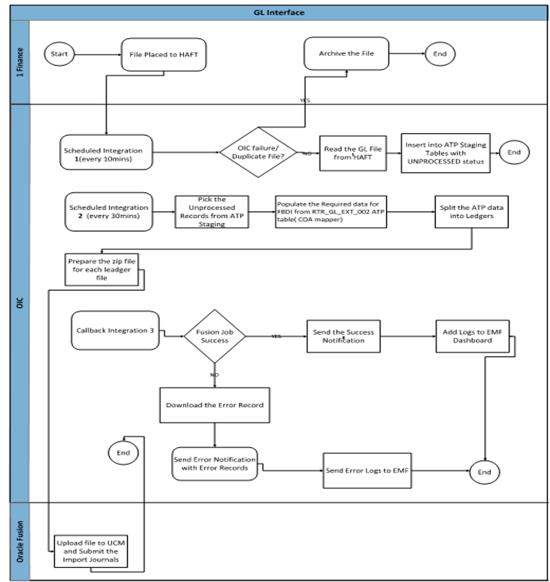

Integration Design
Integration System Name | 1Finance to Oracle Cloud GL
Integration Type | Inbound
Integration Tool | OIC
Orchestration Type | Scheduled
Data Source | 1 Finance
Delivery / Retrieval Service | HAFT
Output/Inbound Filename | 1Fin_GL_To_MAV_17012025055234.txt
File Format | PIPE Separated
Interface Pattern | Batch Processing
Reprocessing | Reprocessing will be done via integration
Encryption/Decryption | No
Purging Requirements | No
Archival Usage | Object Storage
Notification Requirement | Notification for Errors
Direct Outbound Logging | NA

OIC Objects

OIC Integrations
OIC Integration Name | Description
RTR_GL_INT_009_1FINANCE_TO_GL | Scheduled Integrations to list,archive the HAFT files.
RTR_GL_INT_009_1FINANCE_FBDI_LOAD_1 | This integration is used to stage the data and call COA Mapper to get segment values and insert data into Txn table aynchronously
RTR_GL_INT_009_1FINANCE_FBDI_LOAD_2 | This integration uses ledger to get the data from Txn table the prepare the zip and pass it to Oracle Fusion.
RTR_GL_INT_009_1FINANCE_TO_GL CALLBACK | Callback integration to get the status of Processed Files in Oracle Fusion.

OIC Lookups
OIC Lookup Name | Description
GBL_CMN_INTERFACE_DETAILS_LOOKUP | Used to get the values based on RICE ID

OIC Connections
OIC Connection Name | Connection Type | Description
RTR_OIC_REST_CONN | REST | Used to trigger the OIC integration
RTR_ATP_DB_Conn | DB | Used for calling DB for insert/update/select
RTR_ERP_REST_Conn | REST | Used to call REST services from fusion
RTR_HAFT_CONN | SFTP | Used to list/download files
RTR_ERP_CONN | ERP | Used to call FBDI process

Database Objects
Schema | Object Name | Object Type | Purpose
RTR_INT | RTR_GL_INT_009_STG | Table | Stores the 1Finance Data
RTR_INT | RTR_GL_INT_009_GL_IMPT_T | Table | Stores the Transformed FBDI data
RTR_INT | RTR_GL_INT_009_FX_RATE_TYPE_LKP_T | Table | Stores the fx rate type Lookup data
RTR_INT | RTR_GL_CMN_INT_001_LE_VS_LEDGER_T | Table | Stores the  LE vs ledger deatils data
RTR_INT | RTR_GL_CMN_INT_001_CC_VS_RTM_VS_GEO_VS_PC_T | Table | Stores the cc vs rtm,geo,pc data
RTR_INT | RTR_GL_INT_COA_MAPPING_STG | Table | To get the COA Mappings
RTR_INT | RTR_GL_INT_FILE_METADATA_T | Table | Insert the File details Received by 1Finance
RTR_INT | RTR_GL_INT_009_1FINANCE_TO_GL_PKG | Package | Package to insert the 1 finance data into ATP, Validate and Transform into FBDI format.
RTR_INT | RTR_GL_INT_COA_MAPPING_PKG | Package | To get the COA mappings for target system.

Data File Format

Web Services
Short Name | Rest/Soap Webservice | URL

BI Publisher Report Details
NA

FBDI Processing
1. Source File which is PIPE separated will be loaded into ATP database table RTR_GL_INT_009_STG as it is.
2. Then we will insert the RTR_GL_INT_009_STG table data into RTR_GL_INT_009_GL_IMPT_T into the FBDI accepted format.
3. In OIC will split the data of RTR_GL_INT_009_GL_IMPT_T for each ledger_id.
4. Now for each ledger the zip file will be created with file name GL_IMPORT_1FIN_LEDGER_ID_GROUP_ID.zip
5. This zip file will be passed to Oracle Fusion.

Archiving and Purging

- The source data/file will be placed in the archive folder of HAFT post processing.
- The source data/file will be placed to the OIC Object Storage for reference.

File Layout / Report Output

Validation and Error Handling

Sr. No. | Error Scenario | Description | Action
1. | File Duplicate ERROR | This will check whether OIC has processed the FILE earlier and if yes it won’t process the file again. | Will skip the subsequent OIC integrations.
2. | Ledger ID derivation failed | This will check the Ledger Name passed by source file is getting the ledger id from oracle fusion. | Will Skip to pass that ledger data to Oracle Fusion and will be send error via email
3. | Unknow Error | In this case the integration will go to global fault handler | We will send the Email Notification in this scenario to the OIC Support Team.

Application Setup and Technical Requirements

Programs/Report and Parameters

ESS Program, Scheduling and Executables

Security and Controls Requirements

Archiving & Purging

Rollback and Recovery

Miscellaneous

File and Directory Locations
NA

Technical Unit Test
Sr. No | Conditions to be tested | Expected Result | Executed?
1 | Listing the File from HALF and Loading into ATP table | Passed | Yes
2 | Validate duplicate file check during processing. | Passed | Yes
3 | Validate transformation of data into FBDI format. | Passed | Yes
4 | Validate split data for each ledger. | Passed | Yes
5 | Validate upload of ZIP files to UCM. | Passed | Yes
6 | Validate Fusion job submission success. | Passed | Yes
7 | Validate Fusion job submission failure notification. | Passed | Yes
8 | Validate error logging to EMF Dashboard. | Passed | Yes
9 | Error Notification | Passed | Yes

Interface/Conversion Reporting Requirements

Data Validation & Error Reporting
Error Reporting is captured into the Error Management Framework (EMF). EMF is generic portal created for the capturing the error for the OIC integrations.

Data Reconciliation

Open and Closed Issues

Open Issues

Issue Id | Description | Opened By | Responsible | Due Date

Closed Issues

Issue Id | Description | Resolution | Signoff | Closed Date

Appendix

